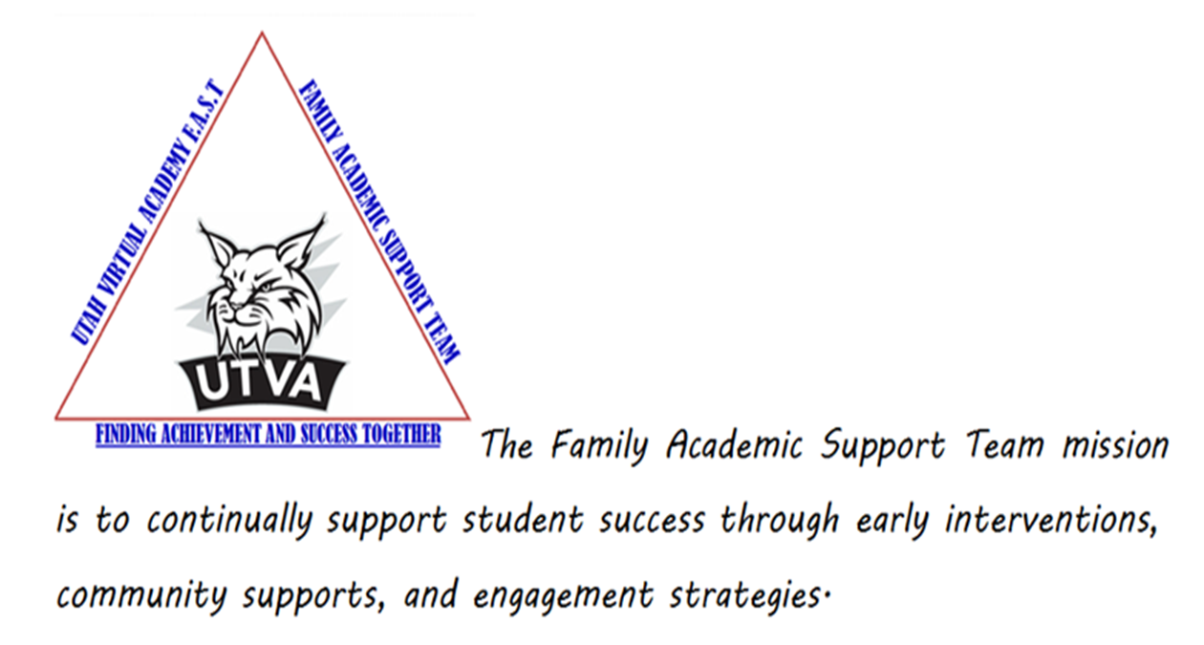

What is the Family Academic Support Team?
Utah Virtual Academy developed a Family Academic Support Team in 2014 with the objective of reducing the number of students who withdraw or become disengaged and providing a more comprehensive support system. The Family Academic Support Team can be likened to an EMT or First Responder to someone needing assistance. The assistance is necessary and mandatory, at least initially. Each family served has differing needs that may need short term support or extended support. The support needed will be determined by the Teacher, Principal and the FAST Lead. Our process is includes academic intervention that will support our struggling students in math and ELA. If a student is placed on the FAST tracker for non-compliancy, it is mandatory that the learning coach/mentor work with the FAST Member assigned to their student.
It is the FAST Member’s job to fill in the gap between the teacher and the family in our virtual world.
When should you refer a student to the Family Academic Support Team?
If you have a family that you notice has some non-compliant issues, or you notice they are struggling during a conference, please contact your principal, so they may be placed on the FAST tracker as soon as possible. The sooner in the school year we have these students, the more likely we are to be able to make a difference with their status. Another good rule of thumb is, if a family does not respond to your requests within two weeks; please complete the google survey to your principal. It is much better to place a referral on the tracker to quickly get some extra support than to wait until the family is way too far behind for us to help. Remember….we are here to help these families become successful with UTVA, but we are also here as your extra support!!
Please see the explanation of tier levels for the Family Academic Support Team below:
- TIER I
  - Compliancy
  - All families start in Tier l receiving support from the teacher
- TIER II
  - General Compliancy
  - Mandated by Support Need
  - Success Plan Implemented
- TIER III
  - Non- compliancy
  - Action Plan Enforced
  - Family Engagement Points assigned if/as needed
- TIER IV
  - Administrative Meeting/Truancy Court/Withdrawal Possible
As a teacher, what can you do when families are non-compliant and unengaged?
2014-2015 Checklist for Teachers (Items to do before referring to FAST)
If you have a family that you notice has some non-compliant issues, or you notice they are struggling during a conference, please place on the FAST tracker as soon as possible. Or if a family does not respond to your requests within two weeks, please place them on the tracker.
WHAT DO YOU DO NEXT?
Now…you have a student who is non-compliant. What do you need to do? The first thing you need to do is
☐Fill out the Compliancy Running Note Form (Appendix A) and add it to the student’s TVS notes.
- ☐ Fill out the Google Survey to your principal. https://docs.google.com/forms/d/1bfecrL1tnlZkA2uLuXusCelBDkDhJZCZduCqs7Cg6sQ/viewform. If the issue is not resolved after Administration contacts family, add the student to the Family Academic Support Team (FAST) tracker

The referral will then be given to one of our Family Academic Support Team Members who will work with you to help get the family back on track. If the FAST Member is unsuccessful in doing so, or the family refuses to work with them, they will then move the student to Tier 3, and we will begin issuing FEPs (Family Engagement Points- or in other words, number and types of attempts to engage student/family).
RUNNING COMPLIANCY NOTE
The only additional thing you, as the teacher, will need to do at this point, is to fill out the “2014-15 Compliancy Running Note” (Appendix A) and copy into a TVS note. In the note you will list every area that the student is non-compliant in. Not just items that they can be FEP’ed for, but this note will list every area of non-compliancy so that when the referral goes to the administration team for possible truancy process, they can pull this note up and see at a glance all the areas that the student needs to improve in. The FAST Member will use this note to find all items that they can FEP for, and e-mail the FEP letter with this information in it to the family (you will be CC’d on it as well). Please find additional information about Family Engagement Points as well as a copy of this FEP letter below. (Appendix F)
Example of a Running Non-Compliancy Note:
8/25/14 KB – SI Learning Pathway – Did not attend.
9/1/14 KB – Math/Writing small group interventions- Did not attend
9/5/14 KB – Called LC. Left voicemail with my contact information asking LC to return my call.
9/6/14 KB- Sent missing attendance kmail to LC. 6 days of missing attendance. Screen shot attached.
9/7/14 KB- Student missed NML. Sent kmail to LC. Did not attend
9/8/14 KB-Called LC. LC stated she wants to be left alone and her student will not be attending class.
9/8/14 KB-Completed Google survey to my administrator for non-compliance.
9/12/13 KB- Student referred to FAST Team. LC notified via Kmail.
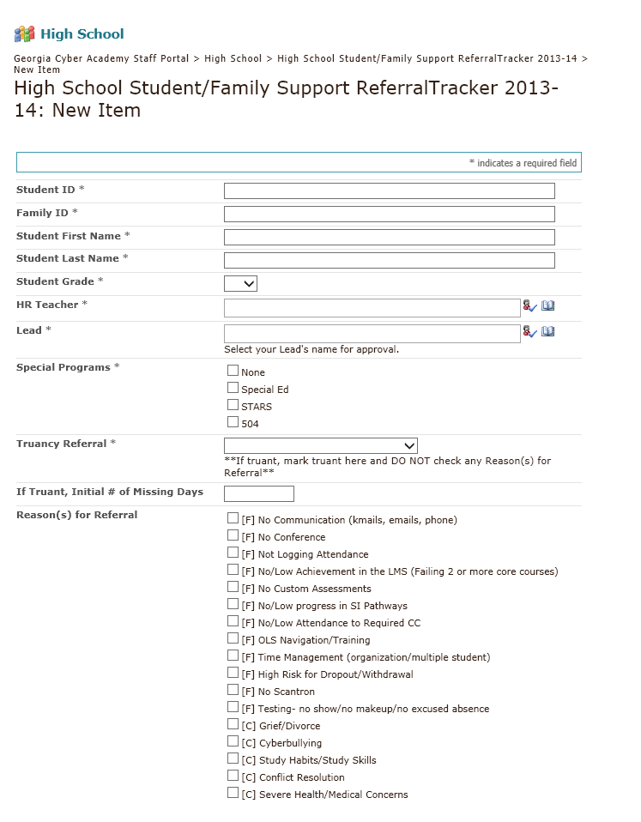

PLA
Academic Intervention – Math or ELA
2014-2015

2014-2015
Utah Virtual Academy
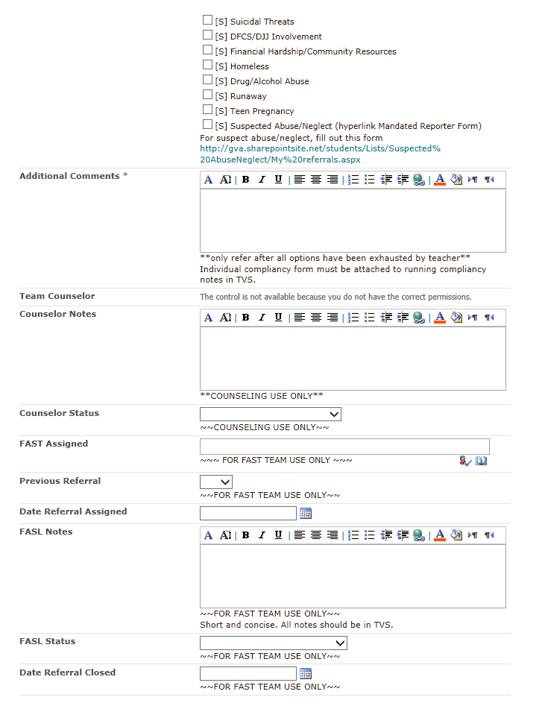
FSL
FSLL

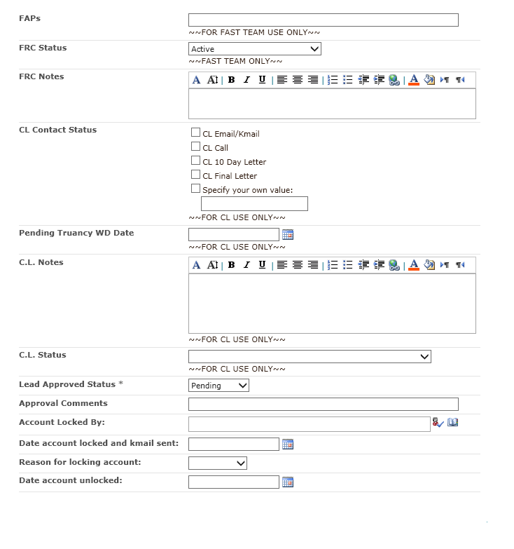
FEP’s

The UTVA FAST Referral Process
TIER II -- After the FAST receives the referral, it will be assigned to a Family Academic Support Team Member who will work with the teacher and Learning Coach/Mentor to help the student meet compliancy. When possible, we would love for the teacher to be present in the meetings with these families so they know we are all on the same page. The FAST Member will create a Back On Track Plan (BOT Plan – See Appendix C). The FAST Member will share it with the LC/Mentor. The LC/Mentor will acknowledge receipt of the BOT and a five or ten-day (calendar days) follow-up will be scheduled with FAST member and Learning Coach/Mentor (it may be sooner than the five/ten days if FAST Member feels family needs additional support).
If family is compliant at the end of 10-days, a 20-day follow-up will be scheduled, and if all is well at that point, referral will be closed and student will be placed back on Tier I (FAST member will send this update to teacher, as well as make notes in SP and TVS). (Please see copy of the first letter that will be e-mailed k-mailed to LC/Mentor by FAST Member (Appendix B) as well as a copy of the BOT Plan (Appendix C) below. If FAST Member is not able to make contact with the family, a No-Contact letter will be sent to them via e-mail and k-mail (see Appendix D) and if no response is made within 24 hours, the referral will be moved to Tier III.
TIER III -- If after the 10-day follow up the family is not compliant, they will be moved to Tier III. At this point they will receive a letter (see Appendix E) explaining what Tier III is. If LC/Mentor begins to work with the FAST member, the FAST Member will share the BOT Plan with them and begin the FAST process all over. If at the end of the plan, the family is compliant, student will be moved back to Tier I or Tier 2 level (depending on if continued support is needed), and referral will be closed.
If the referral is still non-compliant, FEPs will continue to be issued and when the student receives ten FEPs, we will hold a Power Conference meeting will be held to discuss where the student is, and explain that if they do not abide by the BOT Plan from that point forward, they will be moved to Tier IV and the information will be sent to Administration at which point a better placement option for the student will be discussed. Once the student has received five or more FEPs, and the LC is logging attendance while student is on Tier III, but no progress is being made, the FAST Member will start entering attendance for the LC based on work actually completed.
Once a student is placed on Tier IV, please make sure the “2014-2015 Compliancy Running Note” is kept up-to-date in TVS.
TIER IV – Once a student has been moved to Tier IV, their account will be locked by the Compliancy Officer, Truancy court procedures will be started, and they will be submitted for a meeting with the principal to discuss other options for the student that might be a better academic fit. This is our very last resort and is only used for those families who are totally non-compliant. If family chose to withdraw, the FAST lead will send an e-mail, k-mail, and USPS letter to the family informing them of the change in academic placement and withdraw paperwork would be submitted. The FAST Lead will notify the principal. The FAST Member will e-mail the homeroom teacher informing them to process the withdrawal. (see Tier IV letter in Appendix G).
Academic Interventionists
In a data-driven initiative that supports the academic goals of UTVA, the Math and ELA Academic Interventionists also work to support, engage and encourage students and teachers with an emphasis on the content area of Mathematics and English/Language Arts.
Based on PLA data, the Interventionists will start the year by creating classes to meet the needs to struggling students. They will provide support in the following areas:
- Teach required synchronous Class Connect Content Sessions where students will be held accountable for attendance – extra credit in regular core class will be given for attendance in supplemental courses.
- Small group and individual tutoring sessions
- Support with the PLA and other school-wide initiatives

After the first quarter, teachers will refer students based on PLA scores and academic needs demonstrated in Class Connect sessions through the Sharepoint tracker. The same system for referral will be followed as with the FAST team. (Records of attempts to offer TIER II support must be provided, and the Principal must approve the referral.)
- Classes will rotate every 9 weeks; with the Interventionists using a CIA they create to measure student progress. Students can test out of the intervention during the quarter.

- The Interventionists will send out attendance each week, to keep in touch with the homeroom teacher about the students’ attendance.

- The student can earn 1 point for each class attended and these credits can turn into up to 9% additional in extra credit for their grade in either math or ELA/ENG on their report card.

- We will also do a drawing at the end of each quarter for a tablet for all students that have 100% attendance!

- The goal of the Academic Interventionist team is to improve engagement, achievement, satisfaction, and learning for all students.

APPENDIX A
Utah Virtual Academy
2014-15 Compliancy Running Note
Student Name |  | Learning Coach/Mentor
Student ID |  | Grade

Homeroom Teacher |  | Conference Availability (Day):
Contact Number |  | AM/PM:
I have done the following items before placing this student on the tracker:
☐Send a k-mail to the LC, stating that Action is required…letting them know about the specific compliancy issue (for example, attendance needs to be logged in daily).
☐Reach out to family via telephone and/or e-mail to make sure they are aware of requirements if you are unable to reach them by k-mail. Make sure you stress the importance of compliancy from both the LC/Mentor and the student. Specifically cite the UTVA Handbook requirement. Also make sure LC/Mentor is aware of any required e-sessions.
☐“2014-15 Compliancy Running Note” Copy and paste this “Running Compliancy Note” in TVS.
- ☐Completed Google Survey identifying student to Principal. https://docs.google.com/forms/d/1bfecrL1tnlZkA2uLuXusCelBDkDhJZCZduCqs7Cg6sQ/viewform
☐Send LC/Mentor a k-mail letting them know they are being referred to the FAST.
**Principal MUST approve referral to Sharepoint.

Reasons for Referral:
☐ Not logging attendance  ☐ Non-communication (kmail, email, phone)  ☐ No conference  ☐ Non-attendance to required CC  ☐ No to low progress/Low PLA score | ☐ No to low Study Island  ☐ No state mandated activities (BMI, GA411, etc.)  ☐ High risk for Drop Out / W/D  ☐ OLS Navigation  ☐ Time Management (organization, multiple students, etc.)
What items would you want included in the student’s Back On Track Plan? ________________________________
____________________________________________________________________________________________________________

 | Completed | Comments
Handbook signed | Choose an item.
Study Island Pathways | Choose an item.
OLS Progress | Choose an item.
CIA | Choose an item.
SAGE | Choose an item.

PLA/DIBELS | Math | Reading | Conference | LC Attended:
Fall | Choose an item. | Choose an item. | 1st Quarter | Choose an item.
Spring | Choose an item. | Choose an item. | 2nd Quarter | Choose an item.
Progress Up To Date: | Choose an item. |  | 3rd Quarter | Choose an item.
Study Island Assignments Complete: | Choose an item. | Missing Pathways: | 4th Quarter | Choose an item.
Additional Running Compliancy Notes:
APPENDIX B
Introduction Letter
DATE:
Dear LC/Mentor,
My name is ______________ and I am a Family Academic Support Team Member with UTVA. Your teacher has contacted you to let you know that she was reaching out to the UTVA Family Academic Support Team to provide your family with additional assistance to ensure your success in our virtual learning environment.
As your Family Academic Support Team Member, I will:
  - Complement your Teacher’s plan of action for your student’s success
  - Provide an easily accessible forum for additional support
  - Provide encouragement to you as the LC/Mentor
  - Provide specific tools/resources to assist your family
Together, we will form a team to provide you with the tools you will need to be successful in the UTVA program. The Family Academic Support Team can be likened to an EMT or First Responder to someone needing assistance. The assistance is necessary and mandatory, at least initially. Each family served has differing needs that may need short term support or extended support. The support needed will be determined by the Teacher, FAST Member and you as the LC/Mentor. Failure to communicate and effectively work with your FAST Member as a team will automatically place your family on the Tier 3 level for non-compliancy. Please see the explanation of tier levels below.
- TIER I
  - Compliancy
  - All families start in tier l receiving support from the teacher
- TIER II– (You are here)
  - General Compliancy
  - Mandated by Support Need
  - Success Plan Implemented
- TIER III
  - Non- compliancy
  - Action Plan Enforced
  - Family Accountability Points assigned if/as needed
- TIER IV
  - Administrative Meeting/Withdrawal Possible
I am looking forward to getting to know you and your family. Consider me your coach, your cheerleader and your LC/Mentor peer who has the same or similar reasons for wanting to educate my children as you do. Together, we can achieve success and help our children to enjoy the process of learning. I will be in contact with you in a couple of days.
Sincerely,

APPENDIX C
The Back On Track Plan
Date: 9/15/2014 | Conference Mode: Choose an item.
Student: | Student ID:
LC/Mentor: | FAST Member: | Teacher:

This Week’s Lessons to Complete –

Next check-in Friday, September 26, 2014

Teacher | CC Required | Subject | Assignments

Comments:

Student Responsibilities:  - Attend or view and submit survey for ALL Class Connect Sessions on Daily Plan.  - Submit ALL assignments to teacher as required (whether via k-mail or Dropbox).  - Read/respond to k-mails each day. | Learning Coach/Mentor Responsibilities:  - Be sure the student follows the outline above and K-mails the FAST Member each day.  - Log attendance daily.  - Read/respond to k-mails daily.  - Be sure the student is available for weekly conference for the duration of this plan.  - Meet with teacher as required.
Family Academic Support Team Member Responsibilities:
- Read and respond to k-mails.
- Hold a conference with the student and/or Learning Coach/Mentor each week for the duration of this plan.
Positive Consequences: This “Back on Track Action Plan” will cease (after non-compliancy is no longer an issue) and the student will achieve and remain in good standing at Utah Virtual Academy.
Alternative Consequences: FEPS will be issued and if ten FEPs are received, student can be considered for conference on options for other academic placement from UTVA.

A 24 hour response is REQUIRED that you have received and will comply with this letter.

By returning this form, I agree to follow all requirements of this “Back On Track Plan” to comply with UTVA rules and policies. Failure to respond will result with Family Accountability Points being issued for Non-Compliance.

This Week’s Progress Screen Shot:

APPENDIX D
No Contact Letter
DATE

Dear Learning Coach/Mentor,
My name is _________________ and I am a Family Academic Support Team Member with Utah Virtual Academy. I have tried to contact you several times in regard to some non-compliant issues, and haven’t been able to reach you. Please contact me within 24 hours of receiving this letter so we can work on any areas you are having trouble with. Also, please remember that Family Accountability Points (FEPS) can be issued for non-compliancy issues (see page 14 in the UTVA Handbook). Failure to contact this department will result in the student being moved to Tier III and possibly referral to Truancy Court. We are here to help you avoid that, but we need you to contact us as soon as possible to do so. You can reach me at ###-###-####
Thank you!
Sincerely,

APPENDIX E
Tier III Letter

Dear LC/Mentor,
You were referred to the Family Academic Support Team for additional support on_________, to help ensure that your student is successful at UTVA. After several attempts to assist you, there continues to be concerns about non-compliancy. Because of these issues, our Family Academic Support Team met, and we have decided that as of today, ___________________, your student is being moved to Tier Level III where these issues will continue to be addressed, but your student will also begin receiving FEPS for these non-compliancy issues.
Please see the explanation of tier levels below:
- TIER I
  - Compliancy
  - All families start in Tier l receiving support from the teacher
- TIER II
  - General Compliancy
  - Mandated by Support Need
  - Success Plan Implemented
- TIER III – You are Here
  - Non- compliancy
  - Action Plan Enforced
  - Family Engagement Points assigned if/as needed
- TIER IV
  - Administrative Meeting/Discussion on other academic options for student

We look forward to seeing positive results as we work together to improve your status with UTVA. Our goal is to establish a regular school routine and follow the Online School to complete lessons as well as turn in assignments, attend Class Connect sessions, log attendance, read and respond to kmail daily, etc.
If you are willing to begin working with us on a routine basis, your student will remain in good standing at Utah Virtual Academy. Failure to comply means that Family Engagement Points (FEPS) will be issued and if you receive ten or more FEPs, your student will be moved to Tier IV where your student’s non-compliancy issues will be shared with UTVA administration and they will determine the next step in your child’s education at UTVA.
Please call me so we can implement a plan to help get you back on track. Your immediate attention is appreciated. Thank you.
Sincerely,

APPENDIX F
UTVA FEP INFORMATION
With FAST being new this year, I wanted to explain what Family Engagement Points ( FEPs) were…or what the process was for issuing them, so we came up with a plan to help make sure we are all on the same page.
First of all, a FEP is a Family Engagement Point and is used to hold families accountable for any non-compliant issues. Families who enroll their children in the Utah Virtual Academy agree to the “I Understand” statements listed in the UTVA Parent Handbook. These expectations represent the basic minimum to which parents and students must comply in order to experience success in UTVA. Parents are required to fill out the handbook survey stating they have read the UTVA handbook by the end of the first month of school.
The vast majority of families who enroll with UTVA consistently and conscientiously comply with these expectations. However, as the school year progresses, some families may demonstrate the inability or unwillingness to fulfill one or more of the “I Understand” statements. In these cases, the Family Engagement Plan will be initiated so that the school has the mechanism by which the responsible Learning Coach/Mentor can be officially notified of behaviors that compromise the successful school experience of the student. Family Engagement Points (FEPs) will be allocated as necessary until one of two outcomes occurs:
*The family acknowledges their deficiencies and implements programmatic changes to address the issues, resulting in an improved school experience, or
*The family continues to earn FEPs until ten (10) FEPs are reached. If/when this occurs; disciplinary action will be taken and could include a meeting with the Principal to discuss a student’s best educational placement and optional withdrawal from the school. UTVA will notify the district of residence since the student is no longer enrolled in UTVA.
Now that we understand what a FEP is…what do we issue FEPs for?? Please see below:
The chart below explains the possible deficiencies, points and timelines that comprise the Family Engagement Plan:

Issue/I Understand | Point Value | Minimum Expectation | When Recorded
Standardized Testing (Such as but not limited to DIBELS, Writing assessments, PLA, CIA and SAGE) | 1 FEP per day for state mandated tests (student may not enroll the following year) 1 FEP for UTVA tests ie: PLA/DIBELS | Student will take all required state achievement/diagnostic tests | At the end of each testing window
State Mandated Assignments (such as but not limited to CIA or SAGE) | 1 FEP Either is fine 1 for each incomplete grade level requirement | Student will complete all required grade level assignments | At the end of each requirement deadline
Written & Verbal Communication (Kmail) /UTVA Handbook | 1 FEP for not returning signed copy of handbook(s) page and  1 FEP per week for non-compliance with responding to Kmails and phone calls which require a response | Signed copy of Handbook agreement page returned to teacher no later than 9/30 and respond via Kmail to all Kmails requiring a written response | Handbook Agreement FEP assigned end of day 9/30 and written communication FEPs recorded at end of each month
Conferences (parent/ teacher, administrator) | 1 FEP per missed conference or attempted meeting by administration | According to schedule as specified by the teacher(s) and/or administration | Within one week after the missed conference (to give time to reschedule)
Logging into the OLS/LMS | 1 FEP per week per subject for Student/Learning Coach not Logging in (unexcused absences only). 1 FEP per week for minimal to no progress with logged attendance (attendance only) | Student/Learning Coach will log into the OLS daily and meet daily requirements. | Recorded at the end of each week
Family Support Team Back on Track Plan | 1 FEP per Back On Track Plan that is not followed | Student and Learning Coach will follow the Back On Track plan as agreed upon by themselves and the Family Support Liaison | Within one week of the meeting to review the Back On Track plan
Required 3231 (Immunization) and 3300 (Health Examination Card) Medical Forms | 1 FEP per week per student after 60 day deadline for each incomplete form | Parent will submit completed form within 60 days of enrollment. | At the end of each required deadline
Required Scheduled Academic Sessions and /or Related Services | 1 FEP per week for each session/service | As specified in the student’s IEP or ILP | Within one week of scheduled session - to allow time to review recorded sessions and/or attend a makeup session if permissible.

- The Family Support Liaison will keep track of the Family Engagement Points accumulated by the parent/student.
- The Family Support Liaison will keep the parent informed of the student’s FEP status through telephone conferences or via K-Mail.
- Students with IEPs may have additional parent contact, work samples, specialized academic sessions and/or related services requirements (to be determined by the IEP team). Please refer to the Special Education Parent Handbook for specific department requirements.

All appeals will be directed first to the UTVA Administration, who will interview the teacher and the parent/Learning Coach/Mentor, and examine the applicable documentation. The final decision will be made by the Head of School.

Family Accountability Letter
Student Name:
Student ID#
Learning Coach
Grade: Choose an item.

Families who enroll their children in Utah Virtual Academy agree to the “I Understand” statements listed in the UTVA District Handbook. These expectations represent the basic minimum level of participation which parents and students must meet in order to experience success in the Utah Virtual Academy. At this time, a deficiency has been noted in your participation in the area(s) indicated below. For further clarity, we recommend that you review the minimum requirements of enrollment in UTVA as described in the UTVA District Handbook. It is essential that you make every effort to meet these minimum requirements of participation in order to enhance the likelihood of your student’s success in Utah Virtual Academy.

Date Assigned | Reason | Number of FEPs
Click here to enter a date. | Choose an item.
Click here to enter a date. | Choose an item.
Click here to enter a date. | Choose an item.
Click here to enter a date. | Choose an item.
Click here to enter a date. | Choose an item.
Click here to enter a date. | Choose an item.
 | SUBTOTAL
 | TOTAL TO DATE

Comment: Failure to comply with the teacher and requirements of UTVA will result in receiving more FEPs and possible optional withdraw or Truancy court.

Your success is our main priority and the purpose behind the Family Accountability Plan at Utah Virtual Academy. The teachers and administration of UTVA are available via Kmail and phone conferencing if you feel you need additional assistance in order to be successful in the virtual school model.

If you have any questions, please contact me.

Respectfully,

Name
Family Academic Support Liaison
CC: Teacher -
Family Academic Support Team Lead –
APPENDIX G
Tier IV Letter

Dear Learning Coach/Mentor,
You were referred to the Family Academic Support Team for additional support on __________ to help ensure that your student was successful at Utah Virtual Academy. After several attempts to assist you, and continued concerns about non-compliancy, you were moved to Tier III on ___________________. As of today, your student has received ________ FEPs and non-compliancy is still a major concern. Please be advised that your student is now being moved to Tier IV, and withdrawal from UTVA is a very real possibility.
Please see the explanation of tier levels below:
- TIER I
  - Compliancy
  - All families start in tier l receiving support from the teacher

- TIER II
  - General Compliancy
  - Mandated by Support Need
  - Success Plan Implemented

- TIER III
  - Non- compliancy
  - Action Plan Enforced
  - Family Accountability Points assigned if/as needed

- TIER IV – You are here
  - Administrative Meeting/Withdrawal Possible

Your student’s non-compliancy issues are now being shared with UTVA administration where the next step in your child’s education at UTVA will be determined. You will be contacted with this decision as soon as possible.

Sincerely,

Name
UTVA
Family Support Liaison

